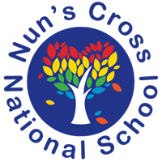
Nun’s Cross National School
Second Class Booklist - September 2019

Dear parents,

We are aware that a number of you have not subscribed for the book rental scheme for the 2019-2020 school year as of yet. With this in mind, we are eager to supply you with the book list which will be required for 2nd class.

Maths Planet Maths 2 (Folens)
Planet Maths 2 Satellite Book (Folens)
Super Sleuth Maths Problem Solving 2nd Class (Gill Education)

English Jolly Phonics Grammar Pupil Book 2
All Write Now; Pre–Cursive 2nd Class (Folens)
Fantastic Mr Fox by Roald Dahl (class novel)
The Butterfly Lion by Michael Morpurgo (class novel)
George’s Marvellous Medicine by Roald Dahl (class novel)

Irish Abair Liom D (Second Class) - Folens 15

If parents wish to sign up to the book rental scheme, the books will be provided at a cost of 60 euro. All textbooks will be written on and therefore will be brought home by the children at the end of the year. Novels will be retained in the scheme. It is important that payment is received or else you let Sandra know before the end of year so that we can order in the correct number of books we require.

Kindest regards,
Ms Ward

